Project Done by;

|  |  |
| --- | --- |
| Name | CWID |
| Fatema Alteneiji | A20362529 |
| Moosa Hana | A20298732 |
| Saurabh Tiwari | A20356308 |
| Ernesto Garcia | A20364089 |
| Chethan Appaji | A20355296 |

Tourist Assist Application

CS487: Software Engineering

Table of contents

Table of Figures 3

User Analysis 4

Requirements Specification 6

Functional requirements: 6

Non-Functional requirements: 7

Functional Requirements Use-case diagrams: 8

High-Level Designs 13

Test Plans 19

Functional Requirement Parameters 19

Non Functional Requirements Parameters 27

Usability: 27

# Table of Figures

Figure 1: Use-case Diagram showing how the application would normally work when the user interacts with it 8

Figure 2: Use-case Diagram showing how the application would normally interact with the user''s location 9

Figure 3: Use-case Diagram showing how the user would normally interact with the search functionality 9

Figure 4: Use-Case Diagram showing how the user can normally interact with reviews 10

Figure 5: Use-case Diagram that shows how the user can normally view the list of the events in the city 10

Figure 6: Use-case Diagram showing how the user can normally view transit points 11

Figure 7: This application showing how the connection to the social network would be 11

Figure 8:Use-case Diagram showing how the user would normally interact with the application to change the language 12

Figure 9: Use-case Diagram showing how the record and recover functionality would normally work 12

Figure 10: Database Diagram for a whole view of the database 13

Figure 11: Entity Relationship Diagram of the databases the application will be using 14

Figure 12: State Transition Diagram for the Tourist Assist Application 15

Figure 13: A sequence Diagram the shows how the user interacts with the application 16

Figure 14: Data flow Diagram that shows the flow of the data in the application 17

Figure 15: Class Diagram the shows the application structure 18

# User Analysis

A research has been done on what possible users might want, in a tourist application, a questionnaire has been given to a number of people in different age groups and different languages, this questionnaire helped the team member gain more understanding of what a tourist application might need to provide to its users, in order for it to be useful to them.

The purpose of that questionnaire was to answer these questions:

* **Who are the users?**

The users of this application are people who are visiting a new place, or planning to visit a new one.

* **What do the users want?**

The tourists mostly want an application that has a simple and efficient interface, one that they can understand and easily use. They want the application to be fast, in case they wanted to used while in a hurry of wanting find a new place to visit at that time, and they would also want the application to support different languages other than English such as French and Spanish, for not all users are fluent or even good with English.

* **What are the users’ goals?**

The tourists’ goals are to have an application that can help them with finding hotels, restaurants, the theatres, and the nightlife in the city. One that also shows them the famous attraction in the city, and the hospitals in case they needed one. They want to be able to read reviews on these places to see what other people think about them.

* **What are individual characteristics that may effect behavior with software or information designed?**

One of the main characteristics that could effect the software is the language of the tourists, the application may be built to accommodate those different languages, another one is the fact that many of them tend to want something to be always available and offers data fast, so the application will be built to accommodate those needs.

* **What do they know that helps them perform their tasks?**

From what the members noticed most of the people these days have at least basic knowledge at using web applications and their mobile phones, and as long as the user interface is built to be simple, most of the tourists should be able to use it.

* **Do they want a user interface that is fun, not boring?**

Many people have answered this question with a yes, but with a request of user experience being simple.

# Requirements Specification

From the user analysis that has been done by the team, a set of requirements has been deduced. The Tourist Assist application will be built on a set of functional and non-functional requirements:

## Functional requirements:

* This application shall be able to find the location of:
  + Hotels
  + Famous Restaurants
  + Museums
  + Shopping malls
  + Hospitals
  + Bars Pubs or Clubs
  + Movies and Theatrical Shows
* This application shall behave in a way such that it can find the location and pin point the coordinates accordingly.
* This application shall have a search functionality that allows to filter the places by price, category, rating and popularity.

This application shall allow the user to view, write reviews and rate the places that have been visited.

* This application should be able to list current events in current city or the one to be visited.
* This application should show transit points
* This application should offer social network connection that the user may use to share his experience.
* This application should support multiple languages: English, French and Spanish.
* This application should memorize the places that have been already visited by the user.

## Non-Functional requirements:

* The application shall be available of most of the time.
* The application should have high performance.
* The application shall allow User Access.
* The application should be reliable.

## Functional Requirements Use-case diagrams:

* This application shall be able to find the location of:
  + Hotels
  + Famous Restaurants
  + Museums
  + Shopping malls
  + Hospitals
  + Bars Pubs or Clubs
  + Movies and Theatrical Shows

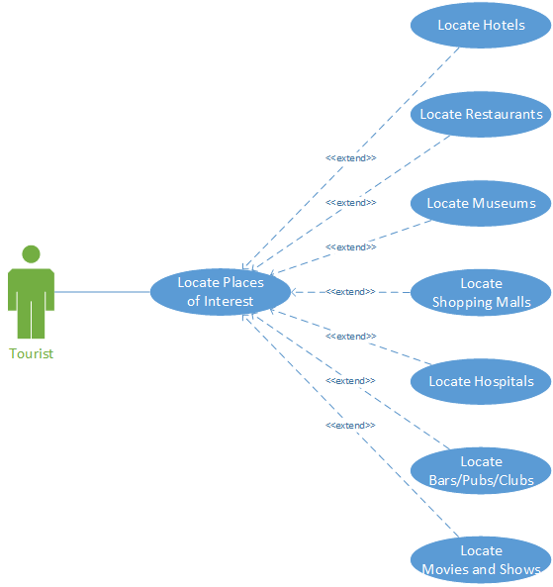

Figure 1: Use-case Diagram showing how the application would normally work when the user interacts with it

* This application shall behave in a way such that it can find the location and pin point the coordinates accordingly.

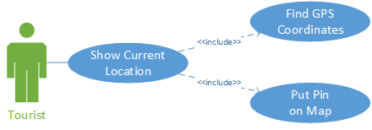

Figure : Use-case Diagram showing how the application would normally interact with the user's location

* 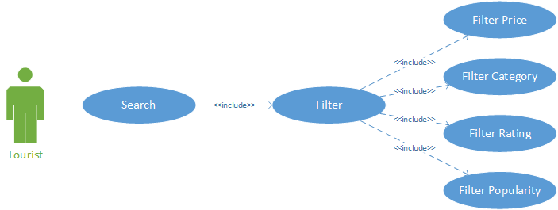This application shall have a search functionality that allows to filter the places by price, category, rating and popularity.

Figure 3: Use-case Diagram showing how the user would normally interact with the search functionality

* This application shall allow the user to view, write reviews and rate the places that have been visited.

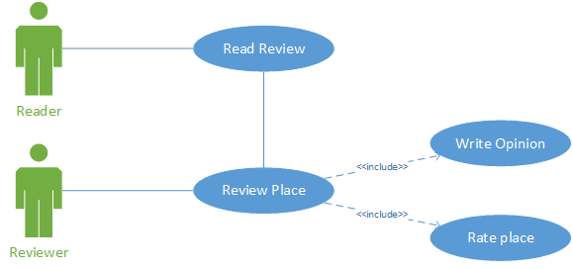

Figure 4: Use-Case Diagram showing how the user can normally interact with reviews

* 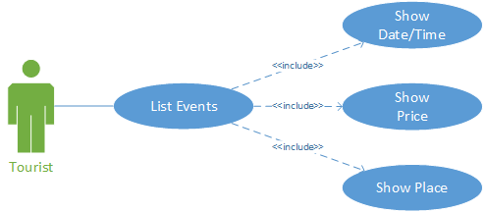This application should be able to list current events in current city or the one to be visited.

Figure 5: Use-case Diagram that shows how the user can normally view the list of the events in the city

* This application should show transit points.

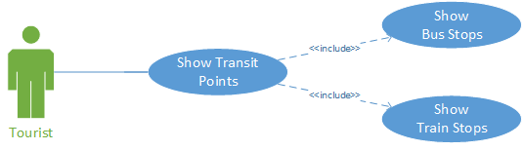

Figure 6: Use-case Diagram showing how the user can normally view transit points

* This application should offer social network connection that the user may use to share his experience.

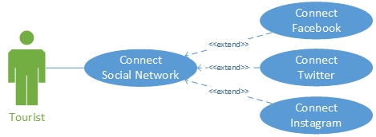

Figure 7: This application showing how the connection to the social network would be

* This application should support multiple languages: English, French and Spanish.

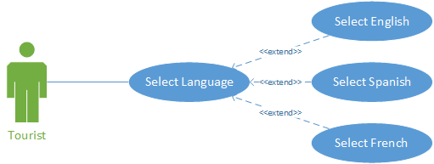

Figure 8:Use-case Diagram showing how the user would normally interact with the application to change the language

* This application should memorize the places that have been already visited by the user.

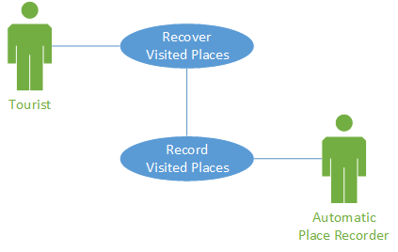

Figure 9: Use-case Diagram showing how the record and recover functionality would normally work

# High-Level Designs

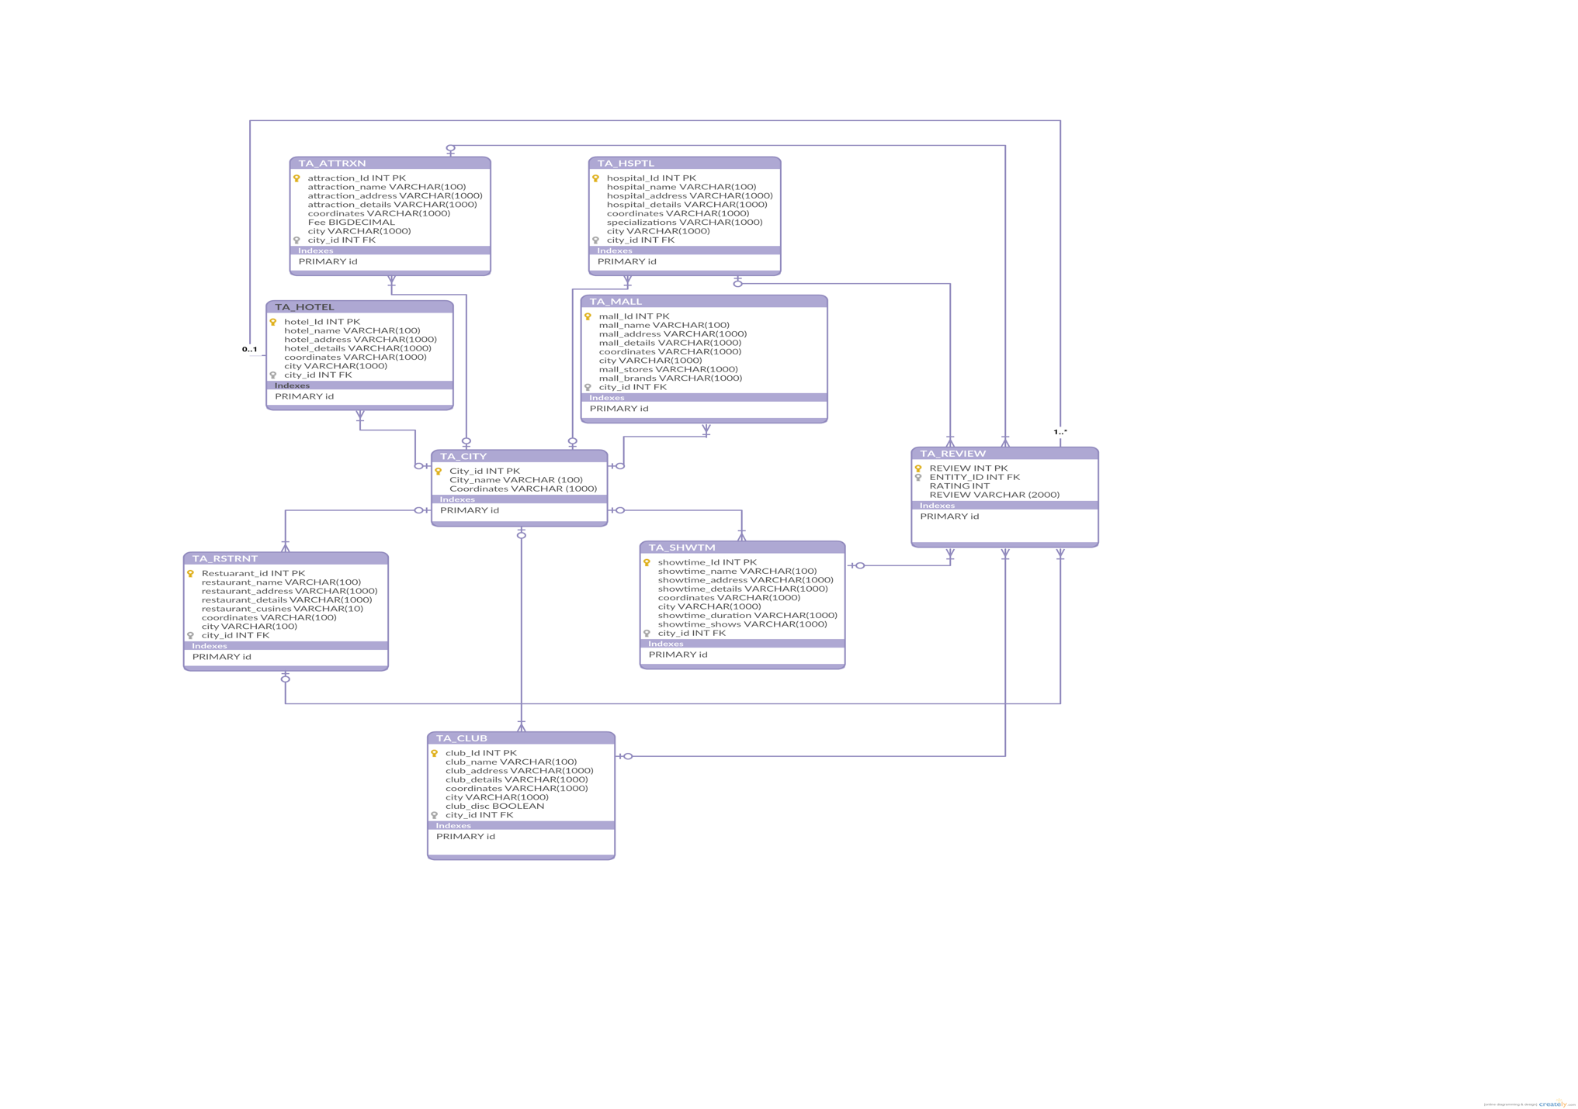Once the decision on what the requirements of this application should be has been made, the team started to build the databases that the application will need to meet the users wants in a tourist application. A database model diagram followed by an Entity Relation Diagram, to show the main tables in the database, the fields they contain and their connections to the other tables.

Figure 10: Database Diagram for a whole view of the database

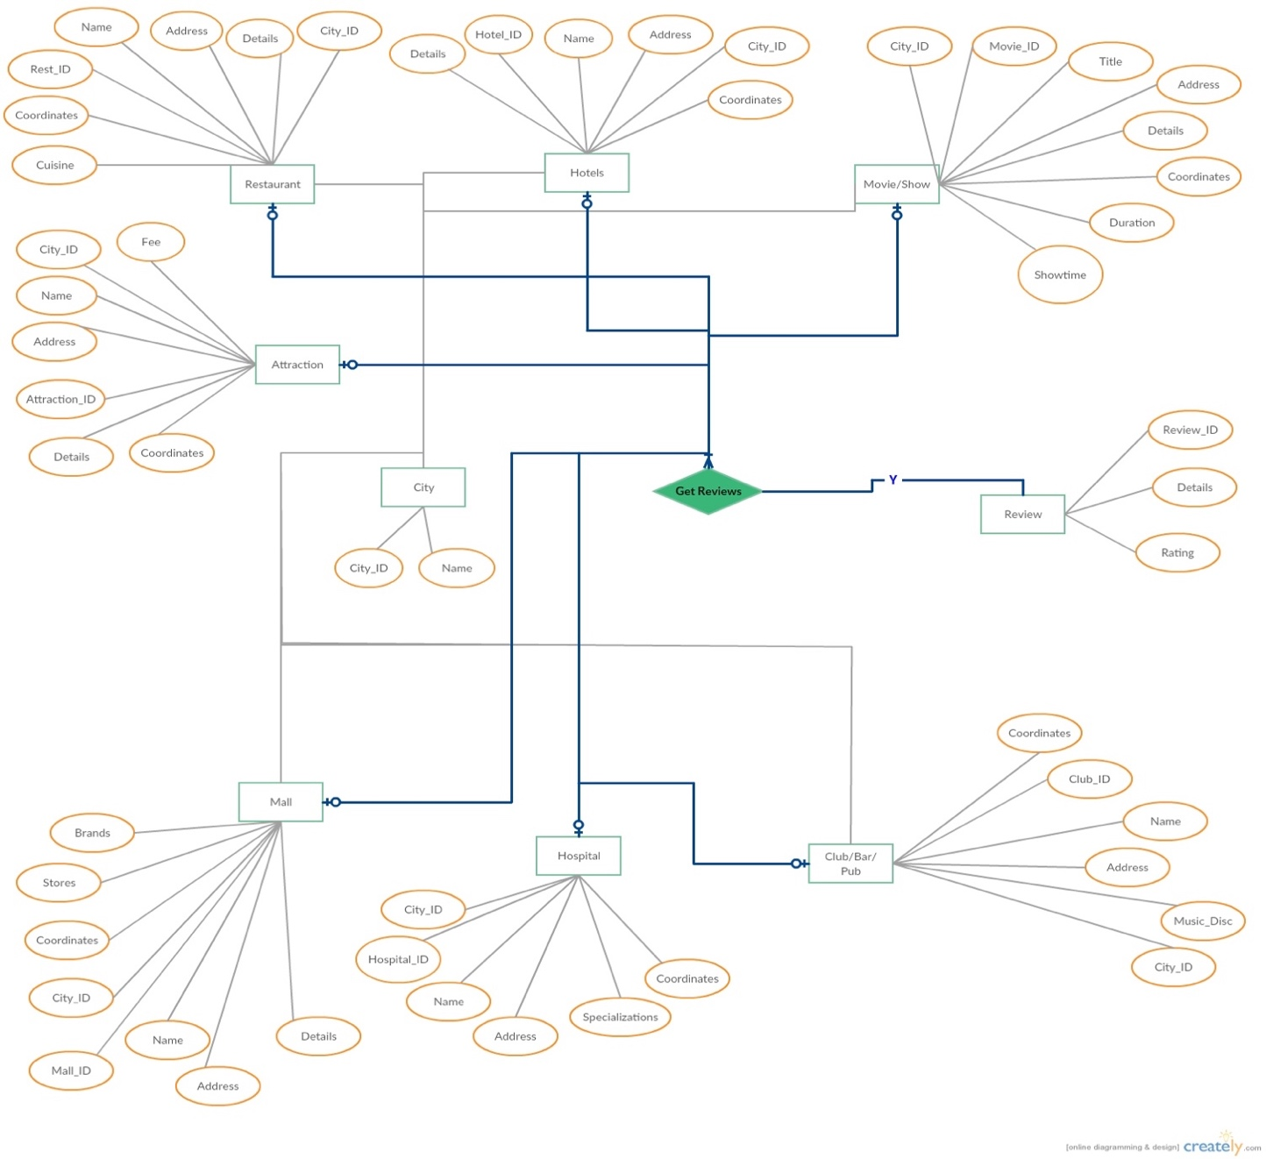

Figure 11: Entity Relationship Diagram of the databases the application will be using

After setting up the database and the required tables, a state transition diagram has been built to clearly state how the application will act, to meet the stated requirements.

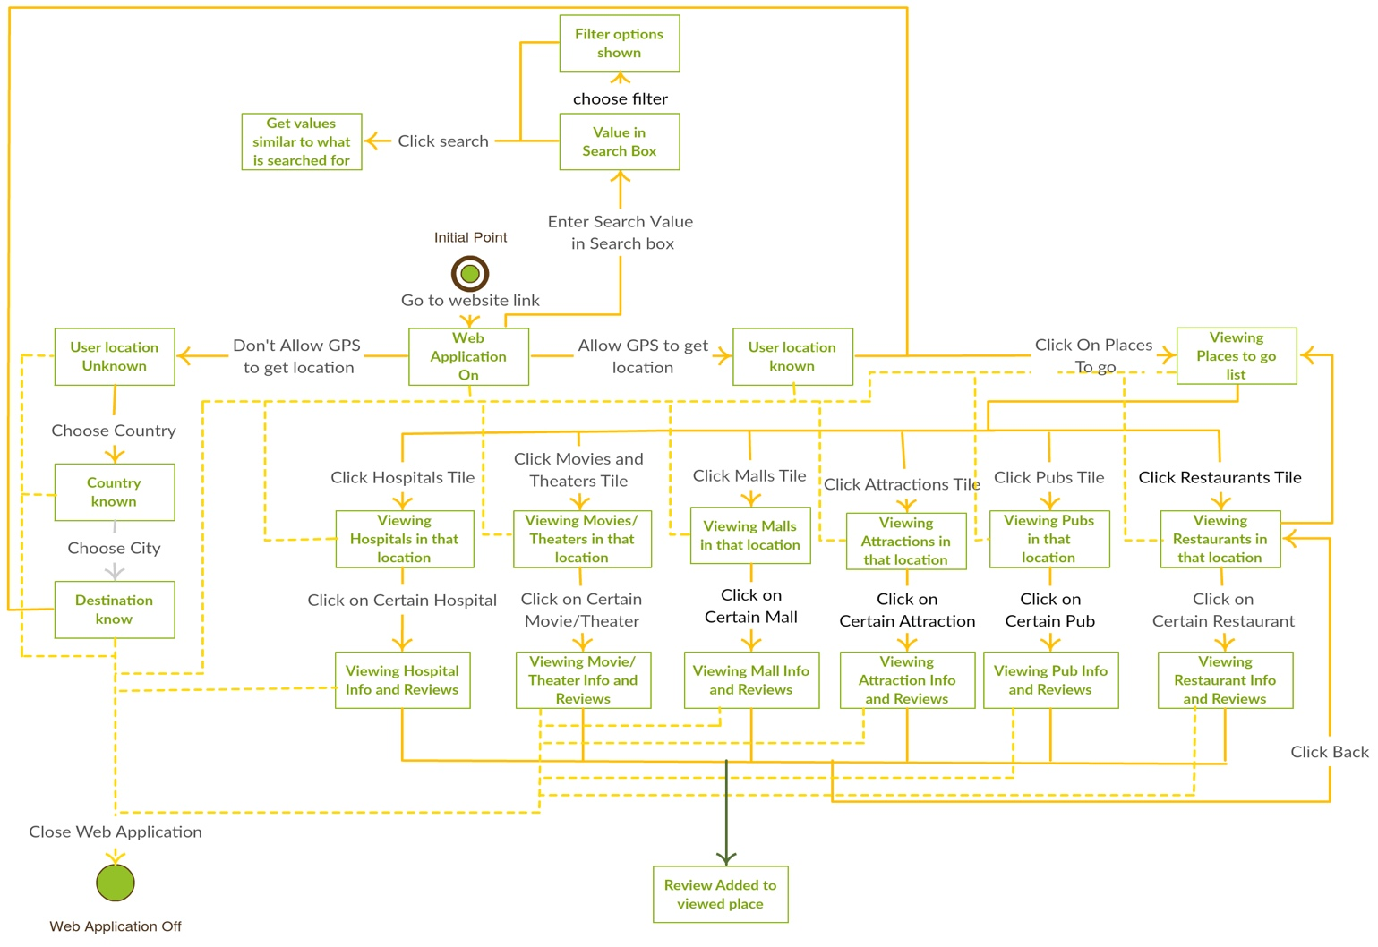

Figure 12: State Transition Diagram for the Tourist Assist Application

Once the state transition diagram was drawn, a sequence diagram depicting the user interaction with the application was drawn.

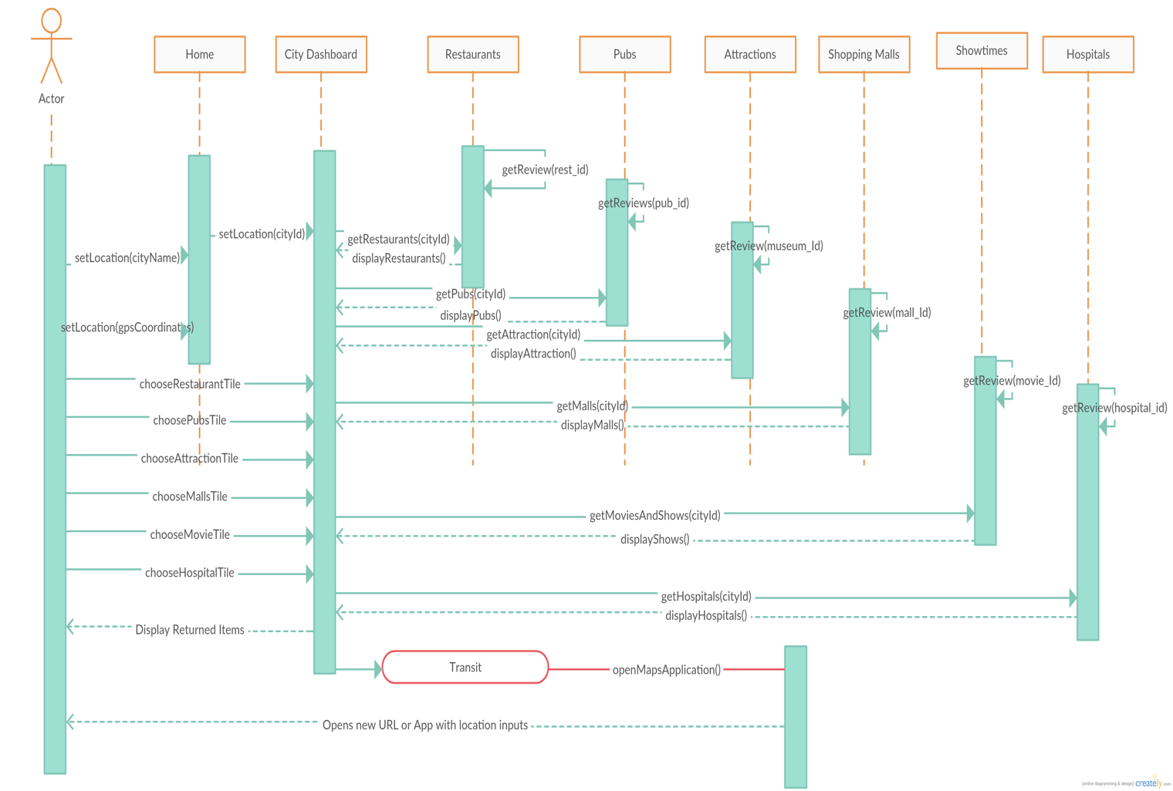

Figure 13: A sequence Diagram the shows how the user interacts with the application

With the sequence Diagram a Data-flow Diagram was also to drown show the data flow through the system.

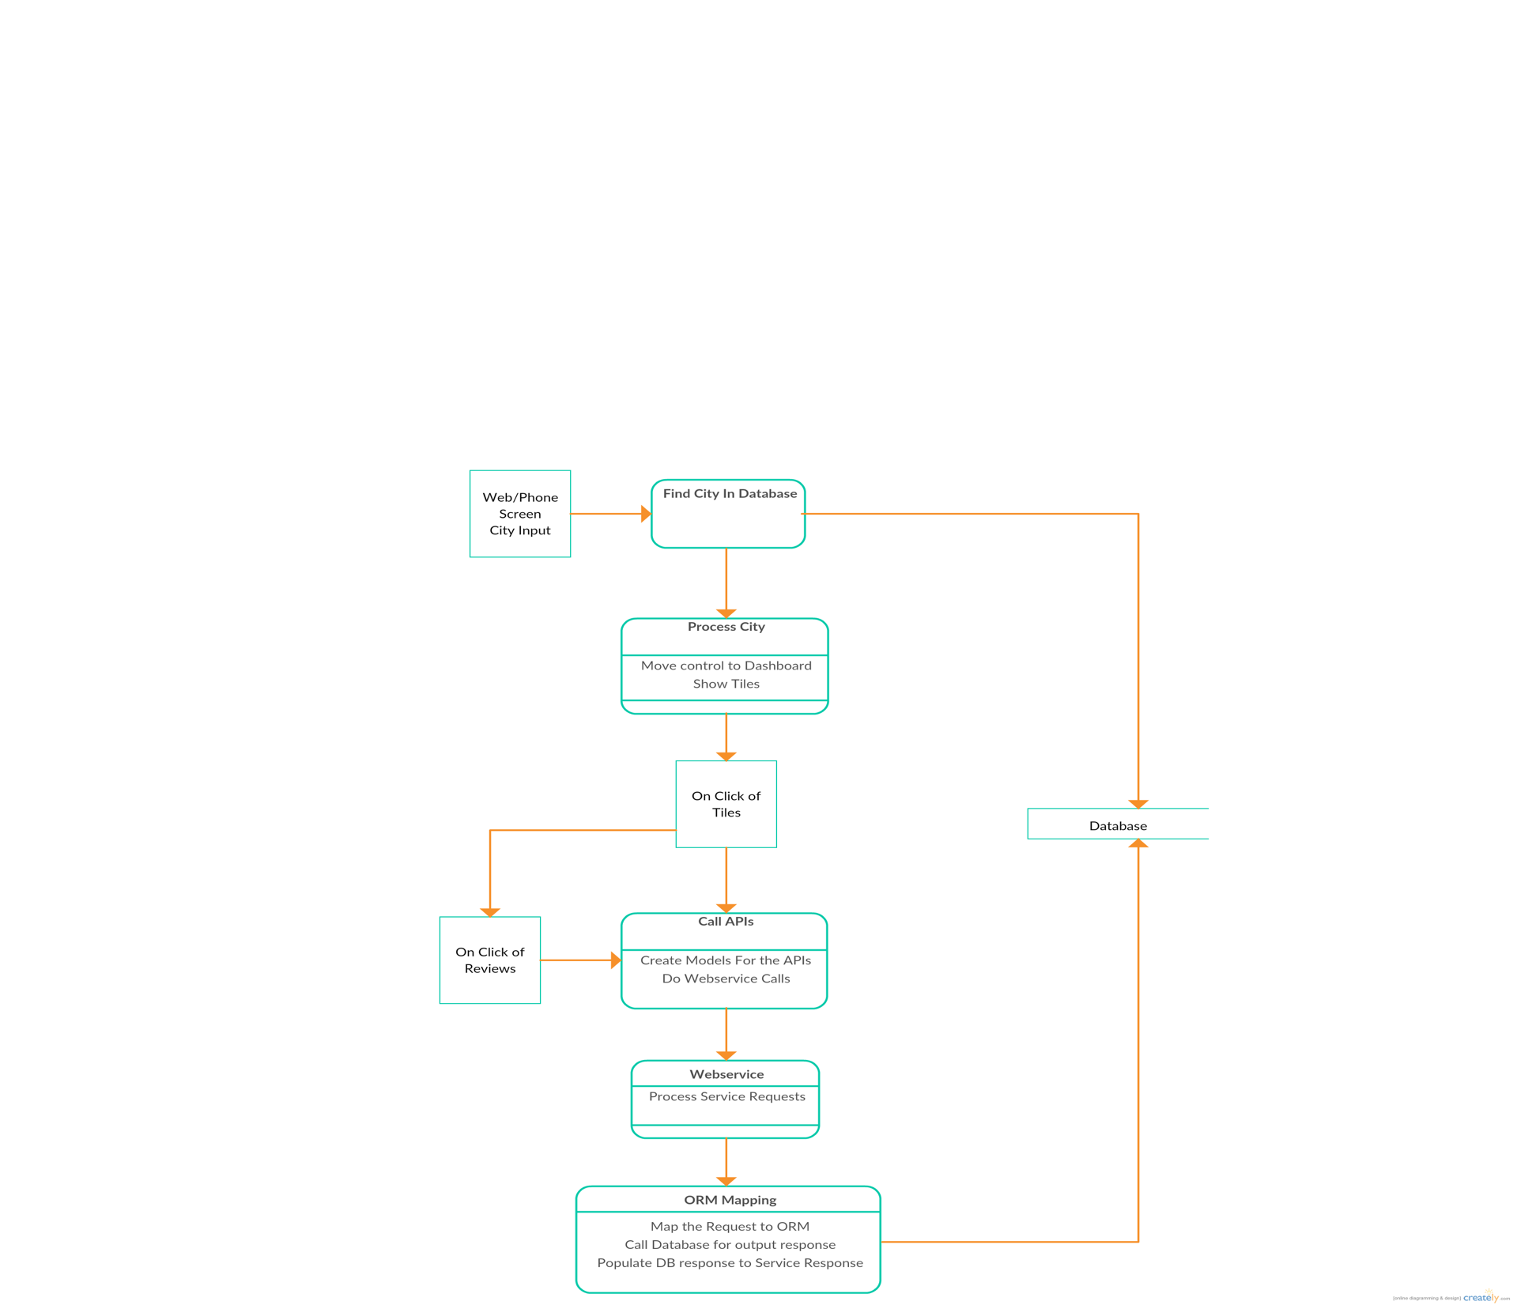

Figure : Data flow Diagram that shows the flow of the data in the application

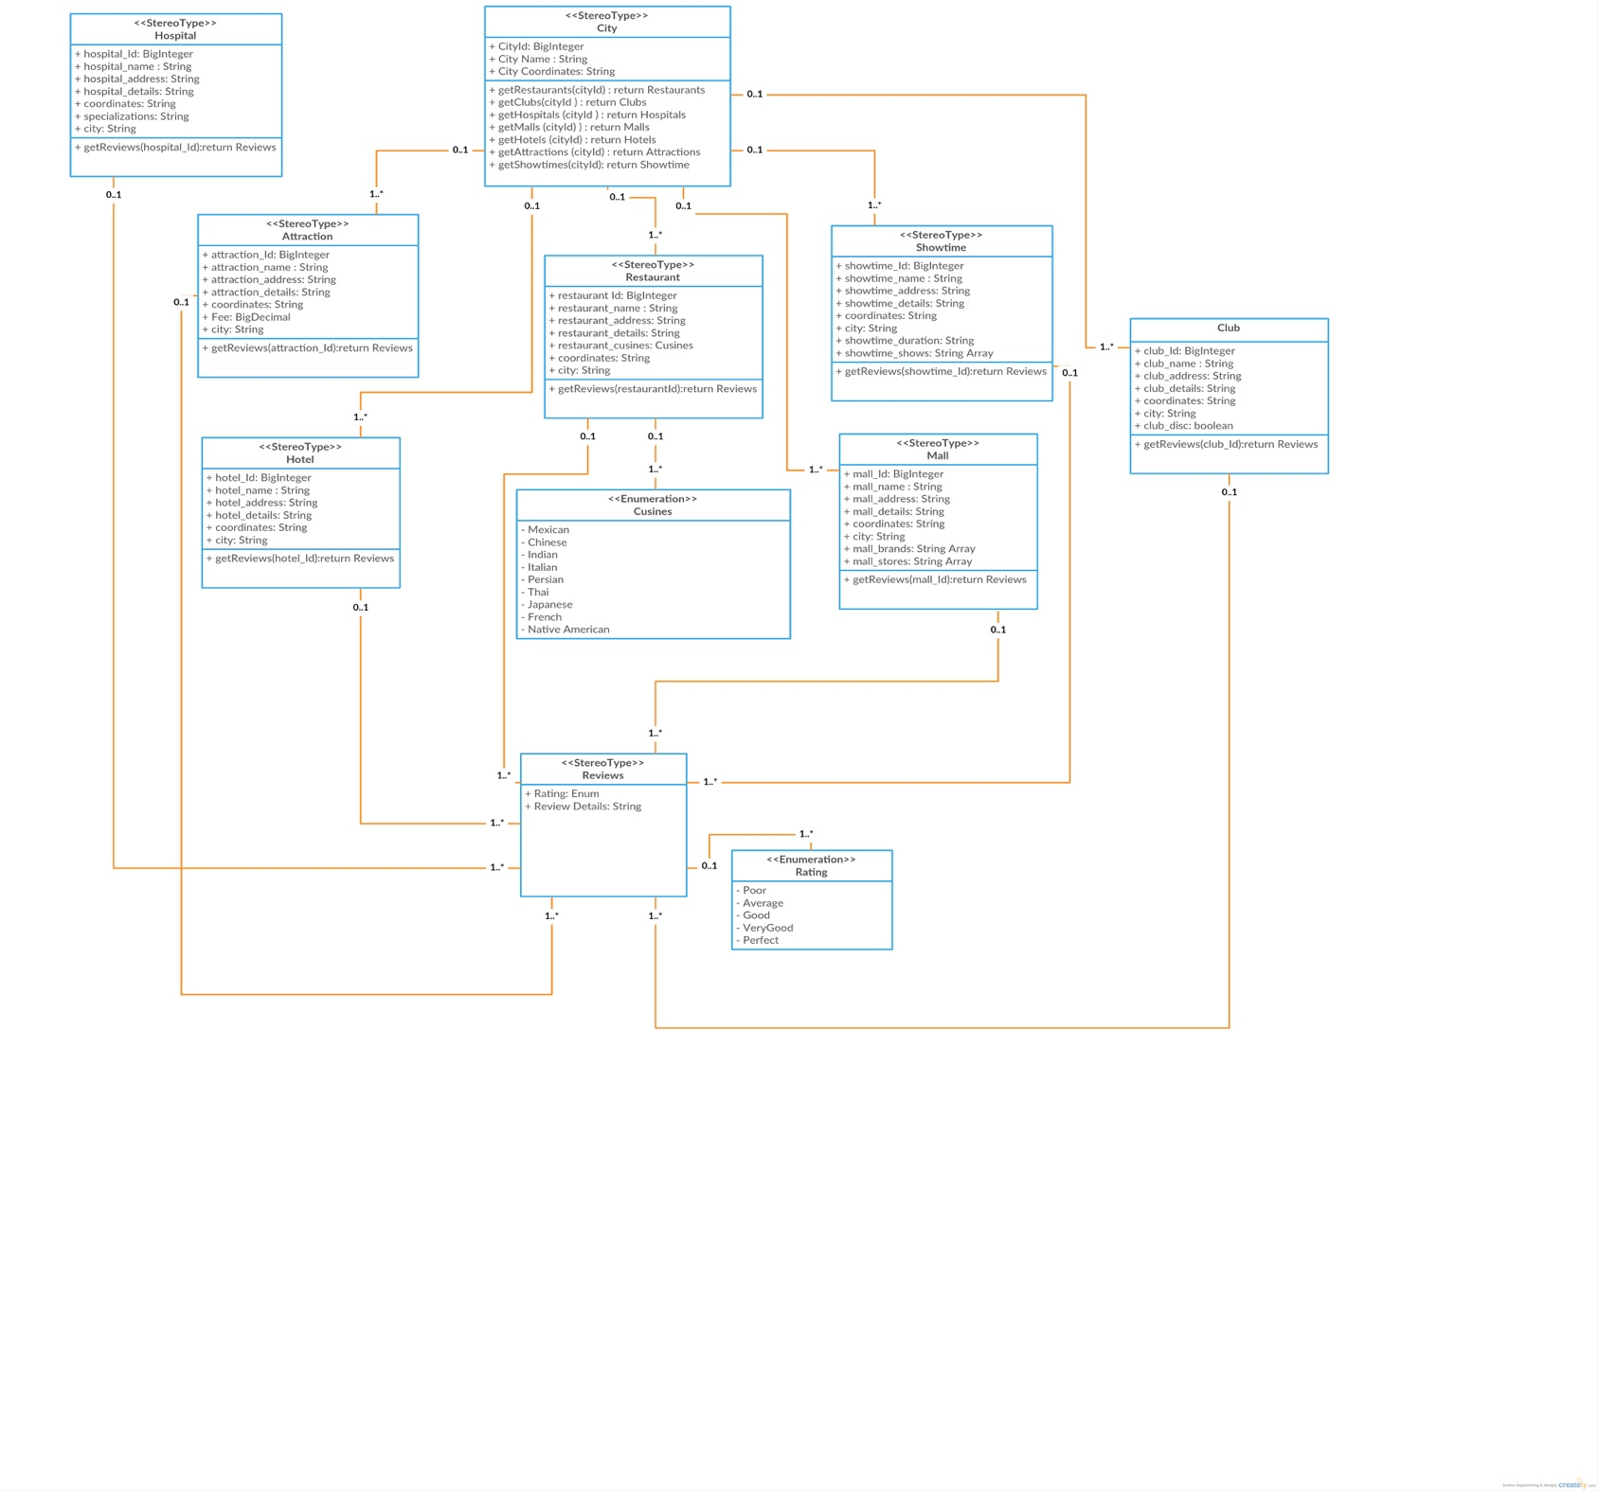A class Diagram that shows the application’s classes was drawn to provide a better view and understanding on the application’s structure.

Figure 15: Class Diagram the shows the application structure

# Test Plans

The followings are some of the scenarios and use cases for different modules of Tourist Assist Application:

## Functional Requirement Parameters

**Use case ID: 1**

Use case Name: Look up for nearby Restaurants and check reviews

Actors: User (tourist)

Description: Test whether user is able to look up for a restaurant nearby current location and get reviews on the selected restaurant.

Precondition: User should have enabled the location services and set the city name for location

Post condition: User should select/click on restaurants and get review option

Normal flow:

1. Open the application.
2. Enable the location services and set location.
3. Look up for restaurants option.
4. Select the restaurant.
5. Click on get review.
6. Close the application.

Exceptions:

1. User is unable to set the location.
2. User is unable to get the nearby restaurants.
3. User is unable to get review.

**Use case ID: 2**

Use case Name: Look up for nearby Pubs and check reviews

Actors: User (tourist)

Description: Test whether user is able to look up for a pub nearby current location and get reviews on the selected pub.

Precondition: User should have enabled the location services and set the city name for location

Post condition: User should select/click on pubs and get review option

Normal flow:

1. Open the application.
2. Enable the location services and set location.
3. Look up for pubs option.
4. Select the pub.
5. Click on get review.
6. Close the application.

Exceptions:

1. User not able to set the location.
2. User not able to get the nearby pubs.
3. User not able to get review.

**Use case ID: 3**

Use case Name: Look up for nearby Attractions and check reviews

Actors: User (tourist)

Description: Test whether user is able to look up for attractions nearby current location and get reviews on the selected attraction/museum.

Precondition: User should have enabled the location services and set the city name for location

Post condition: User should select/click on attractions and get review option

Normal flow:

1. Open the application.
2. Enable the location services and set location.
3. Look up for attractions option.
4. Select the attraction/museum.
5. Click on get review.
6. Close the application.

Exceptions:

1. User not able to set the location.
2. User not able to get the nearby attractions.
3. User not able to get review.

**Use case ID: 4**

Use case Name: Look up for nearby Shopping Malls and check reviews

Actors: User (tourist)

Description: Test whether user is able to look up for shopping malls nearby current location and get reviews on the selected mall.

Precondition: User should have enabled the location services and set the city name for location

Post condition: User should select/click on shopping malls and get review option

Normal flow:

1. Open the application.
2. Enable the location services and set location.
3. Look up for shopping malls option.
4. Select the mall.
5. Click on get review.
6. Close the application.

Exceptions:

1. User not able to set the location.
2. User not able to get the nearby shopping malls.
3. User not able to get review.

**Use case ID: 5**

Use case Name: Look up for Showtime of a movie nearby and check review of the movie.

Actors: User (tourist)

Description: Test whether user is able to look up for a show time nearby current location and get reviews on the selected movie.

Precondition: User should have enabled the location services and set the city name for location

Post condition: User should select/click on show time and get review option

Normal flow:

1. Open the application.
2. Enable the location services and set location.
3. Look up for show time option.
4. Select the movie.
5. Click on get review.
6. Close the application.

Exceptions:

1. User not able to set the location.
2. User not able to get the nearby show time.
3. User not able to get review.

**Use case ID: 6**

Use case Name: Look up for nearby Hospitals and check reviews

Actors: User (tourist)

Description: Test whether user is able to look up for a hospital nearby current location and get reviews on the selected hospital.

Precondition: User should have enabled the location services and set the city name for location

Post condition: User should select/click on hospitals and get review option

Normal flow:

1. Open the application.
2. Enable the location services and set location.
3. Look up for hospitals option.
4. Select the hospital.
5. Click on get review.
6. Close the application.

Exceptions:

1. User not able to set the location.
2. User not able to get the nearby hospitals.
3. User not able to get review.

**Use case ID: 7**

Use case Name: Look up for Transit availability

Actors: User (tourist)

Description: Test whether user is able to look up for a transit nearby current location.

Precondition: User should have enabled the location services and set the city name for location.

Post condition: User should select/click on transit and input the name of the destination.

Normal flow:

1. Open the application.
2. Enable the location services and set location.
3. Look up for transit option and click on it.
4. Opens Maps Application (opens new URL or app with location inputs).
5. Enter the destination.
6. Close the application.

Exceptions:

1. User not able to set the location.
2. Maps application is not loaded.
3. User unable to enter location inputs.

**Use case ID: 8**

Use case Name: Search functionality with various filters

Actors: User (tourist)

Description: Test whether user is able to use a search functionality and do a search using different filters available.

Precondition: User should have enabled the location services and set the city name for location

Post condition: User should select/click on search option and apply filters if needed

Normal flow:

1. Open the application.
2. Enable the location services and set location.
3. Select/click on search option.
4. Click on filters (optional).
5. Close the application.

Exceptions:

1. User not able to set the location.
2. Search option not available.
3. Unable to load filters.

**Use case ID: 9**

Use case Name: List Events across current location

Actors: User (tourist)

Description: Test whether user is able to look up for events across the current location and list them.

Precondition: User should have enabled the location services and set the city name for location

Post condition: User should select/click on list events option

Normal flow:

1. Open the application.
2. Enable the location services and set location.
3. Select/click on list events option.
4. Close the application.

Exceptions:

1. User not able to set the location.
2. List events option not available.
3. Unable to load part or complete result of events.

**Use case ID: 10**

Use case Name: Connect to Social Network site

Actors: User (tourist)

Description: Test whether social network option is available and user is able to connect to.

Precondition: User should have enabled the location services and set the city name for location

Post condition: User should select/click on social network option/pane and choose the site to connect

Normal flow:

1. Open the application.
2. Enable the location services and set location.
3. Select/click on social network option/pane.
4. Click on various site options available.
5. Close the application.

Exceptions:

1. User not able to set the location.
2. Social network option/pane not available.
3. Unable to connect to social network site.

## Non Functional Requirements Parameters

|  |  |
| --- | --- |
| Non Functional requirement Matrix | Level(High/Low/Medium) |
| Performance | High |
| Scalability | Medium |
| Capacity | High |
| Availability | High |
| Reliability | Medium |
| Extensibility | Medium |
| Usability | High |

## Usability:

In the tourist assist app, user groups are

* Tourist – of different age group, and different native languages